**SQL PROJECT**

**FOODIE CRUSH**

* ***ABSTRACT***

A Delicious Exploration

The recipe portal is a virtual tempting haven designed to inspire educate and delight food enthusiasts of all levels, our platform is dedicated to the art of cooking, offering a vast collection of recipes, tasty resources and a growing community of passionate cooks



* Key features of recipe portal

1. Diverse Recipe Collection:-

Access a collection of recipes spanning cuisine, testy preference and skill levels. From mouth-watering desserts to tangy entrees, this 0portal serves to all tastes.

2. User- Friendly Interface:-

Navigate this natural interface with ease. Discover recipes, save favorites and can share yummy creations effortlessly.

3. Interactive Cooking Guide:-

Step-by-step cooking instructions, along with detailed ingredient lists and cooking tips, empower both beginners and experienced chefs to succeed in the kitchen.

4. Personalization:-

Fit users tasty journey by creating a user's profile, saving recipe and receiving personalized recipe recommendations based on users preferences.

5. Community Engagement:-

Connect with fellow food enthusiasts, exchange idea and engage in lively discussions within our community forums.

6. Mobile Accessibility:-

Enjoy this recipe portal on the go with responsive design, ensuring a seamless experience on both desktop and mobile devices.

Whether an experienced chef looking to expand tasty repertoire or a beginner taking first steps in kitchen, the Recipe Portal is gateway to world yummy possibilities.

* ***Aim of Project***:-

**The main aim of this project is to build a management system which will help in Recipe Portal to function smoothly in order to provide desired results and that too on time and will also maintain records of the Portal's various entities which will help it to function in an organized manner.**

***❖ Objective of Project:-***

* The portal will be able to maintain the records of all the entities like Users, Recipe, Ingredient, Category, and Comment.
* It will create permanent organized relational records about the Users which have helped to obtain particular Recipe.
* It will give details about Recipes and Ingredient being used for particular Recipes.

***ER Diagram***

**USERS**

-ID

Provides

User_Name

User_ID (PK)

-id

Join_Date

Email

City

Used For

**RECIPES**

Recipe_ID (PK)

**COMMENTSSSS**

Comment_ID (PK)

Recipe_Name

Comment

Prep_Time

Cook_Time

**CATEGORY**

**INGREDIENT**

Recipe_ID (FK)

Servings

User_ID (FK)

Ingredient_ID (PK)

Category_ID (FK)

Ingredient_Name

Works

Description

Recipe_ID (FK)

Category_ID (PK)

Category_Name

**STRUCTURE OF TABLES**

**Users:-**

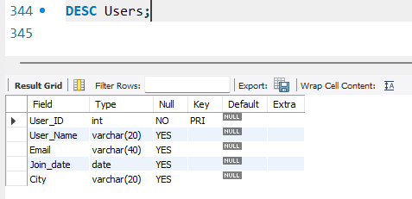

**Recipe:-**

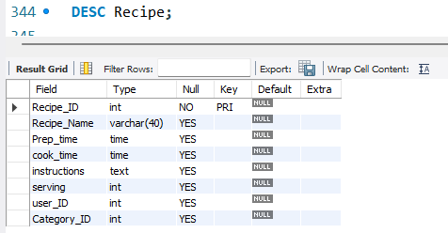

**Ingredients:-**

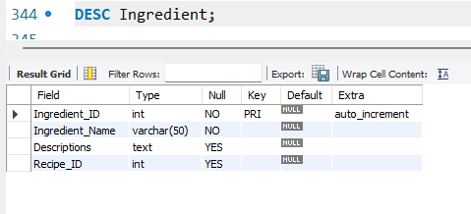

**Category:-**

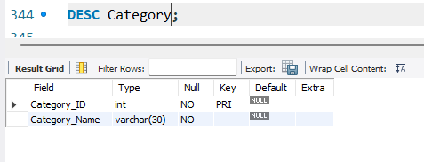

**Comments:-**

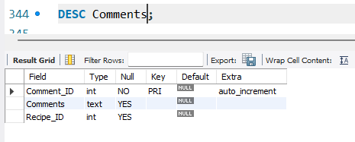

**Contents of Tables**

**Users:-**

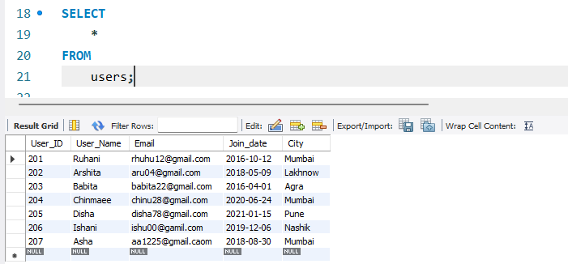

**Recipe:-**

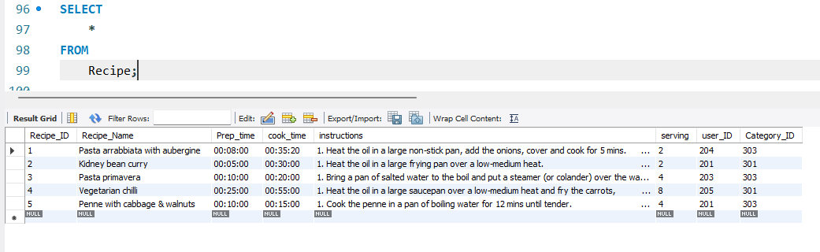

**Ingredients:-**

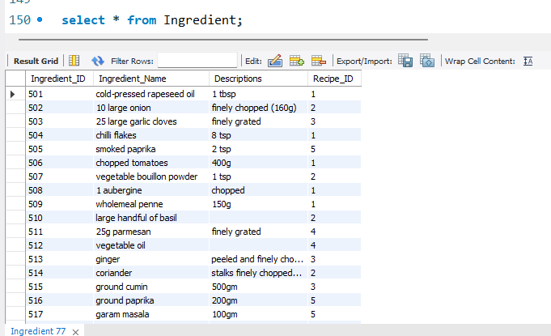

**Category:-**

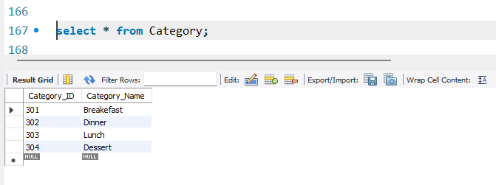

**Comments:-**

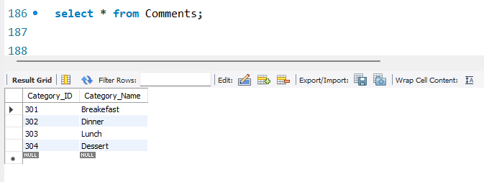

**DQL QUERY:**

**Like Operator**

1. Find the recipe with “PASTA” in their title.

Query:

SELECT Recipe_Name

FROM Recipe

WHERE Recipe_Name LIKE '%Pasta%';

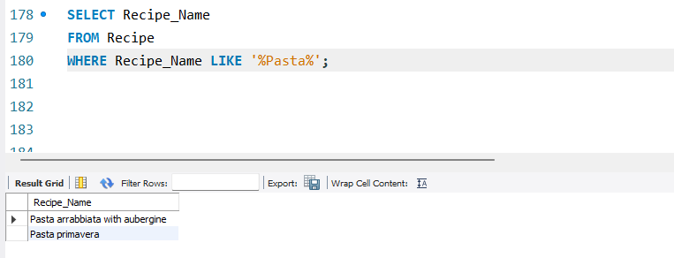

1. Retrieve users whose last letter is A

Query:

SELECT * FROM Users

WHERE User_Name like '%A';

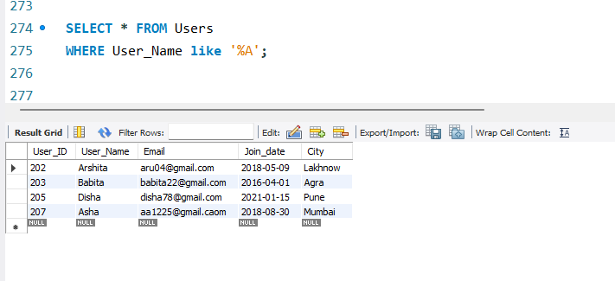

1. Display Ingredient_ID and Ingredient_Name whose Recipe_ID is 1 and 2

Query:

SELECT Ingredient_ID, Ingredient_Name, Recipe_ID

FROM Ingredient

WHERE Recipe_ID in (1,2);

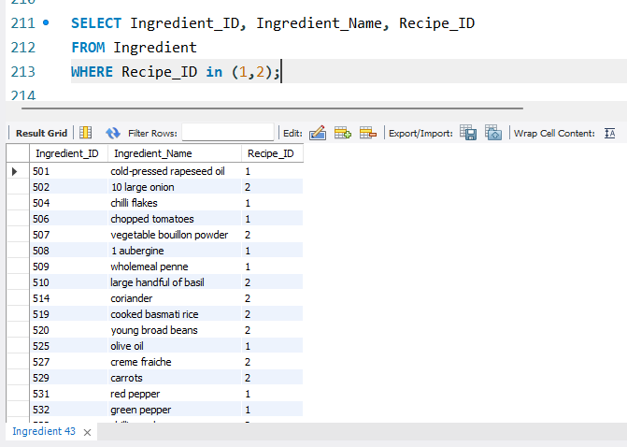

1. Retrieve users whose either from "Mumbai" or "Lakhnow"

Query:

SELECT *

FROM Users

WHERE city in ('Mumbai', 'Lakhnow');

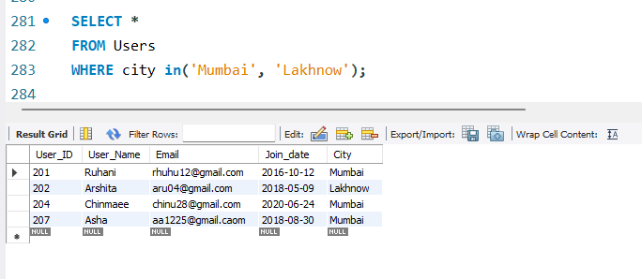

1. List the most recent user join to the portal

Query:

SELECT *

FROM Users

ORDER BY Join_date DESC;

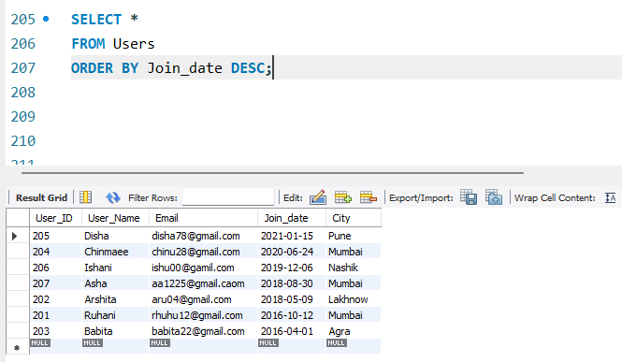

1. Retrieve Recipe according to preparation time in descending order

Query:

SELECT *FROM Recipe

ORDER BY Prep_Time DESC;

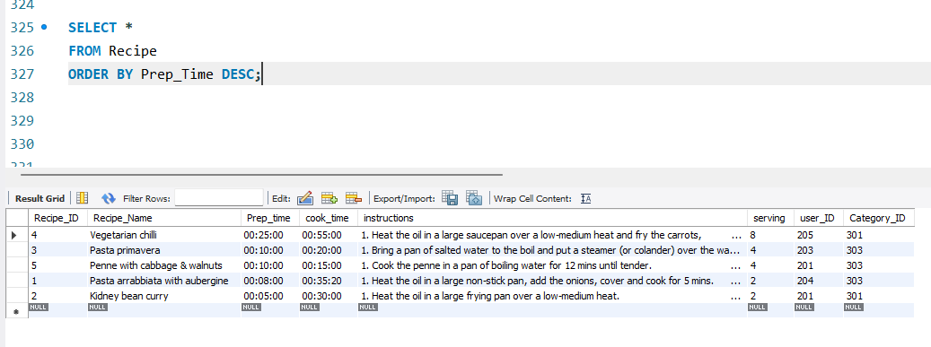

1. Retrieve the quickest recipe

Query:

SELECT *, Cook_Time

FROM Recipe

WHERE Cook_Time IS NOT NULL

ORDER BY Cook_Time ASC

LIMIT 1;

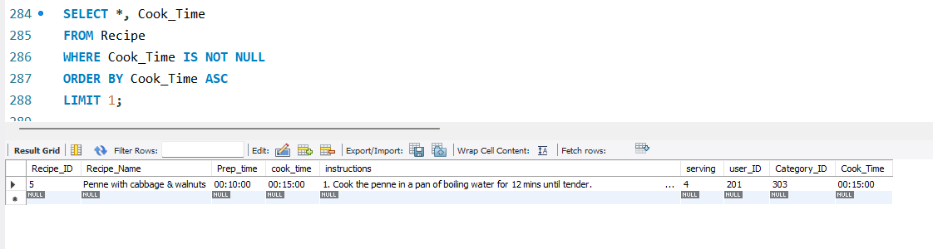

1. Retrieve the Recipe_ID and Recipe_Name whose recipe has not been commented

Query:

SELECT Recipe_ID, Recipe_Name

From Recipe

WHERE Recipe_ID NOT IN (SELECT Recipe_ID FROM Comments);

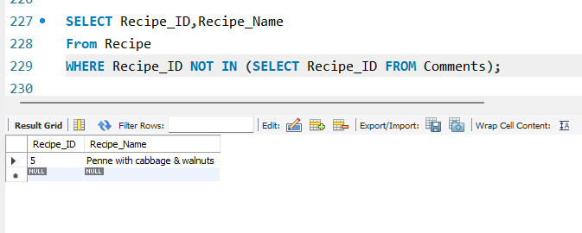

1. Retrieve the ingredients used in recipe_ID "3"

Query:

SELECT *

FROM Ingredient

WHERE Recipe_ID= 3;

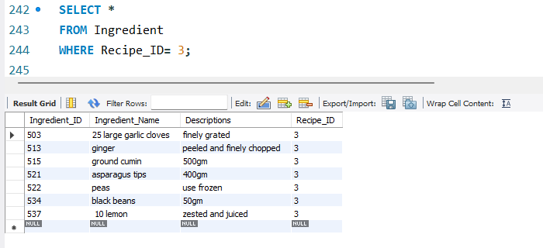

1. Retrieve users from distinct city's

Query:

SELECT distinct City

FROM Users;

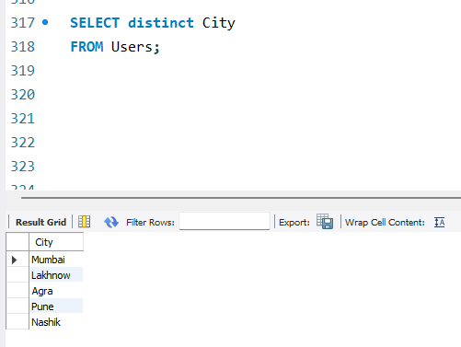

**Aggregate Function:**

1. Fetch total number of users from various cities

Query:

SELECT City, COUNT (*) AS TotalUsers

FROM Users

GROUP BY City;

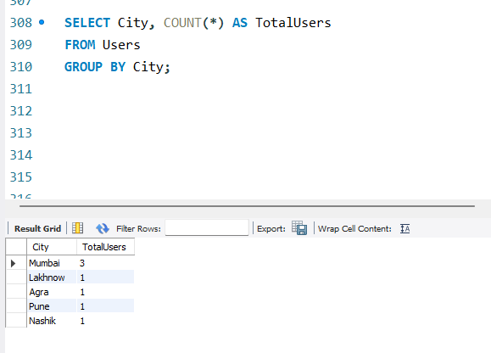

**SUB –QUERY:**

1. Retrieve the third highest cooking time taken by recipe

Query:

SELECT max(Cook_Time)

FROM Recipe

WHERE Cook_Time < (select max(Cook_Time) from Recipe where Cook_Time < (select max(Cook_Time) from Recipe));

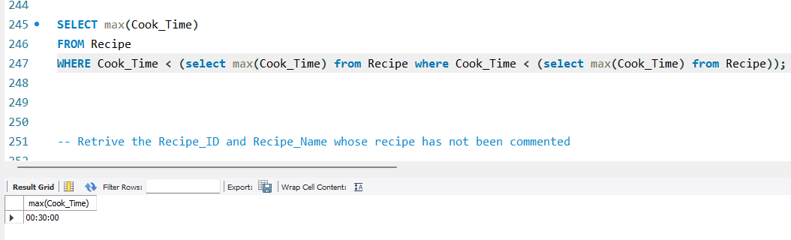

1. Find recipe in a category "Lunch"

Query:

SELECT *

FROM Recipe

WHERE Category_ID IN (SELECT Category_ID FROM Category WHERE Category_Name = 'Lunch');

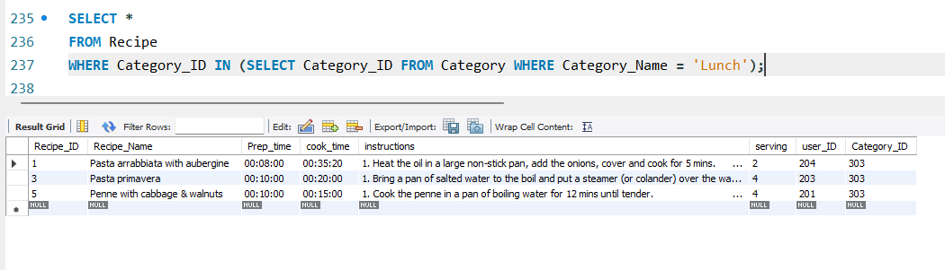

**JOIN:**

1. Retrieve the number of comments for each recipe

Query:

SELECT R.Recipe_Name, COUNT(C.Comment_ID) AS CommentCount

FROM Recipe R

LEFT JOIN Comments C ON R.Recipe_ID = C.Recipe_ID

GROUP BY R.Recipe_Name;

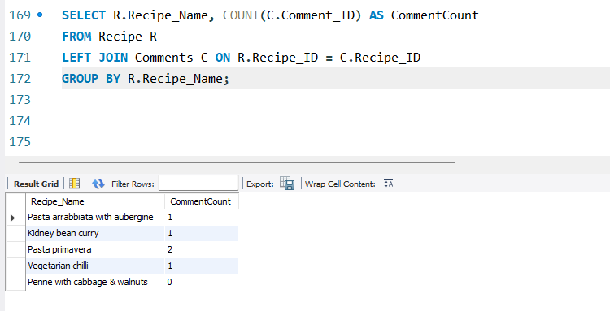

1. Retrieve all the recipe titles and their author’s usernames

Query:

SELECT R.Recipe_Name, U.User_name

FROM Recipe R

JOIN Users U ON R.User_ID = U.User_ID;

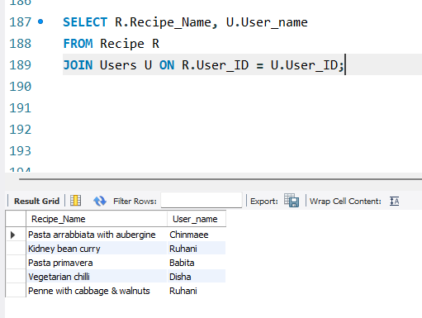

1. Retrieve recipes with a "onion" ingredient in it\

Query:

SELECT R.Recipe_Name, I.Ingredient_Name AS Ingredient

FROM Recipe R

JOIN Ingredient I ON R.Recipe_ID = I.Recipe_ID

WHERE Ingredient_Name = 'chili flakes';

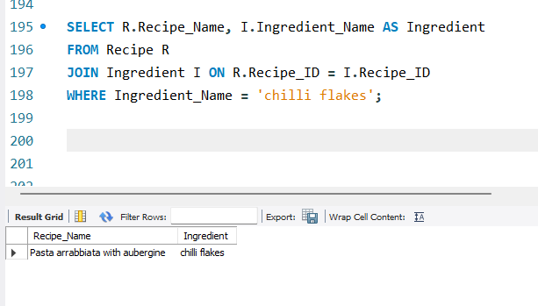

1. Retrieve users which didn't posted recipe yet

Query:

SELECT U.User_Name, U.User_ID

FROM Users U

LEFT JOIN Recipe R ON U.User_ID = R.User_ID

WHERE R.Recipe_ID IS NULL;

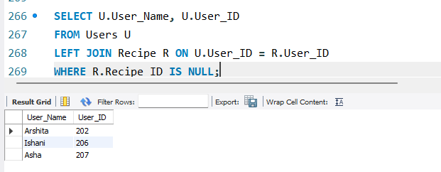

1. Retrieve User_ID, User_Name and Recipe_ID, Recipe_Name

Query:

(Select U.User_ID, U.User_Name,

R.Recipe_ID, R.Recipe_Name

From Users U

Right outer join

Recipe R

On U.User_ID =R. User_ID);

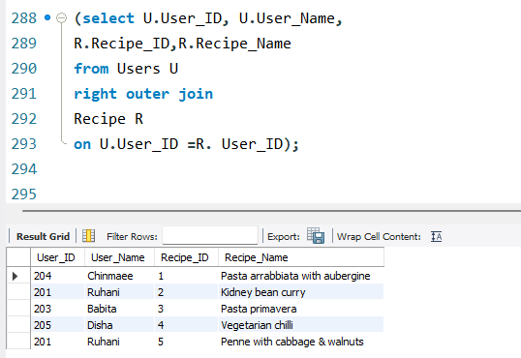

**DATE AND DAY FUNCTION:**

1. Retrieve all users vintage till date

Query:

SELECT *, datediff (curdate (), Join_date) as Vintage

FROM Users;

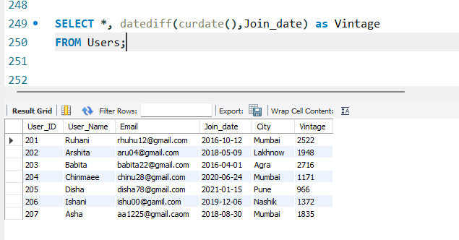

1. Retrieve the Joining day of Users as Joining_Day

Query:

SELECT *, dayname (Join_Date) as Joining_Day

FROM Users;

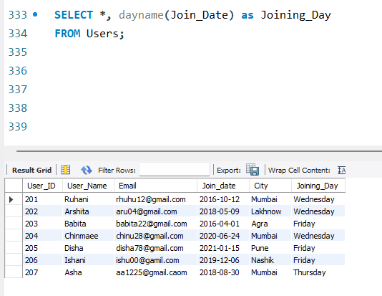

**Built in SQL – String Functions:**

1. Retrieve all Recipe_name in Capital letter

Query:

SELECT upper (Recipe_Name)

FROM Recipe;

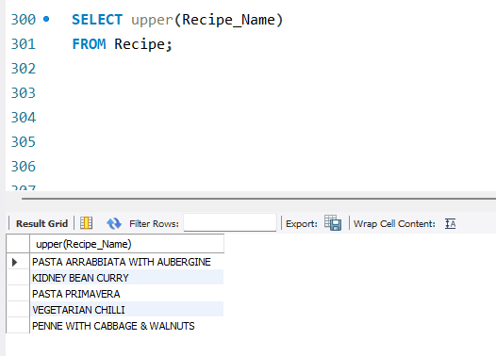

1. Retrieve all User_Name in small letter

Query:

SELECT lower (Recipe_Name)

FROM Recipe;

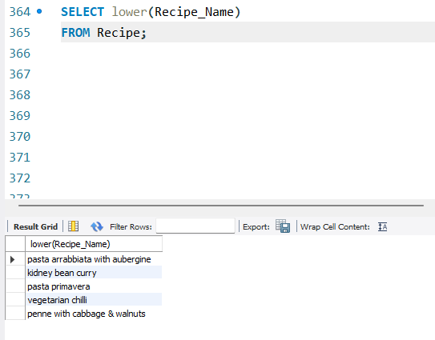

1. Retrieve all character length of Recipe_Name

Query:

SELECT char_length (Recipe_Name) from Recipe;

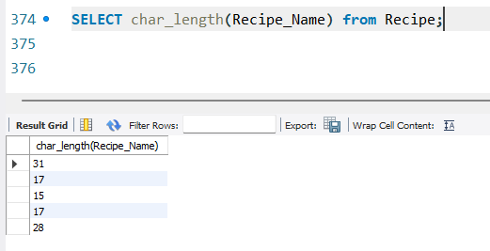

**DDL QUERY:**

1. Add column "Ratings" in comment table

Query:

ALTER TABLE Comments

Add column Rating int;

